PROJECT 1 :TYPING SPEED CALCULATOR



NAME. : Vinayak Shivaling Vijayanagar

USN : 1EP21AD057

G MAIL : rani.vini.viddi.sakshi@gmail.com

# ACKNOWLEDGEMENT

While I was making this project , a lot of information that I found helped me in chapter and I am glad that I was able to complete this project and was able to understand many things.

It gave me an immense pleasure while doing this project because it was not just a project but , a source to learn not just about chapter but also I inculcated many qualities like responsibility , punctuality , confidence and what not.

The journey of making this project was so nice and in all this my teachers who supported me all the time , cleared my doubts and the parents support also played a big role and my friends too helped me . I thank to all of them and wish that they keep supporting me like this.

Doing work on time is something everyone needs to learn and through this project I have improved my timing and also it made my thinking skills better .

A project is a bridge between theoretical and practical learning and with this thinking I worked on the project and made it successful due to timely support and efforts of all who helped me.

Once again thank you Sir/Ma'am to give me this project and to make me learn so many things .I have no more valuable words to express my thanks , but my heart is still full of favor received from every person

ABOUT THE C0MPANY:

Varcons Technologies Pvt Ltd is a digital service provider that aims to provide software, designing and marketing solutions to individuals and businesses. At VCT, we believe that service and quality is the key to success.

We provide all kinds of technological and designing solutions from Billing Software to Web Designs or any custom demand that you may have. Experience the service like none other!

Some of our services include:

Development - We develop responsive, functional and super-fast websites. We keep User Experience in mind while creating websites. A website should load quickly and should be accessible even on a small view-port and slow internet connection, We develop sophisticated customizable softwares using Java and other programming Languages as per the clients needs’

Mobile Application - We offer a wide range of professional android, iOS & Hybrid app development services for our global clients, from a start up to a large enterprise.

Design - We offer professional Graphic design, Brochure design & Logo design. We are experts in crafting visual content to convey the right message to the customers.

Consultancy - We are here to provide you with expert advice on your design and development requirement.

Videos - We create a polished professional video that impresses your audience

# INDEX

|  |  |  |
| --- | --- | --- |
| NO.S | TITLE | PAGE NO. |
| 1 | Brief overview on project | 01 |
| 2 | Advantages and challenges while completing project | 01 |
| 3 | Software and hardware requiement for project | 02 |
| 4 | Implementation of project | 03-05 |
| 5 | Conclusion | 06 |
| 6 | Bibliography | 07-08 |

**A BRIEF OVERVIEW ON THE PROJECT**:

This Java project is a general-purpose, concurrent, class-based, object- oriented computer programming language that is specifically designed to have as few implementation dependencies as possible and it helps to learn how to define and call the function in code.

It is intended to let application developers "write once, run anywhere" (WORA), meaning that code that runs on one platform does not need to be recompiled to run on another and from doing this project we get know about class must allow the objects to cooperate during the execution

# 2.ADVANTAGES AND CHALLENGES WHILE COMPLETING THE PROJECT.

This project has advantage of giving the user a understanding of his /her speed in typing the words and characters, also mentioning the correct accuracy of typed words. THE TYPING SPEED CACULATOR done has levels to it such as easy , medium , hard indicating the user speeds in various conditions given the randomness in words and sentences given helps the user to achieve more accuracy through his /her practice in the typing speed. Finally the WPM , CPM and accuracy is output for various levels user completes.

On the other hand the code of various levels that was to be done was challenge along with the time calculated for each input and the usual problems like use of inbuilt functions and minor problems in methods were faced often but overcome in final result.

**SOFTWARE AND HARDWARE REQUIRMENTS FOR JAVA PROJECT :**

# Hardware Requirement for Java :

Minimum hardware requirement to download Java on your Windows operating system as follows:

* Minimum Windows 95 software
* IBM-compatible 486 system
* Hard Drive and Minimum of 8 MB memory
* A CD-ROM drive
* Mouse, keyboard and sound card

# Software requirement for Java :

Nowadays, Java is supported by almost every operating systems. Whether it is a Windows, Macintosh and Unix all supports the Java application development. So you can download any of the operating system on your personal computer. Here are the minimum requirement.

The software require for project includes package necessary to successfully compile and build the program.

* Operating System
* Java SDK or JRE 1.6 or higher
* Java Servlet Container (Free Servlet Container available)
* Supported Database and library that supports the database connection with Java.

IMPLEMENTATION OF THE PROJECT with Screenshots:

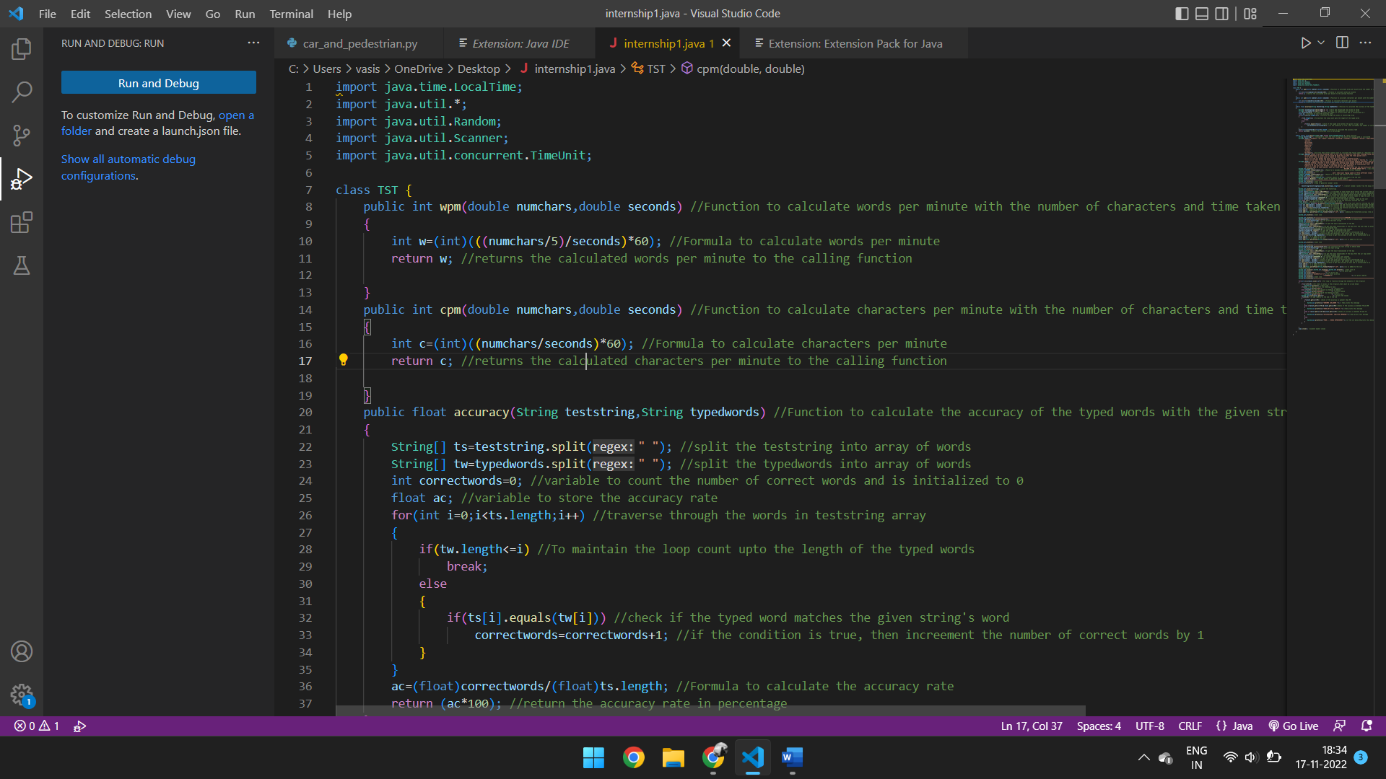

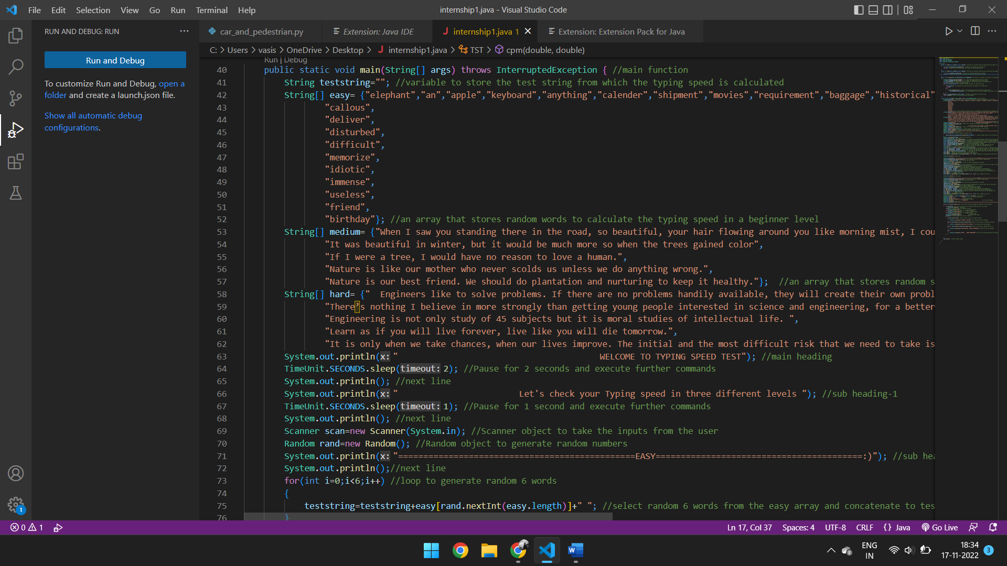

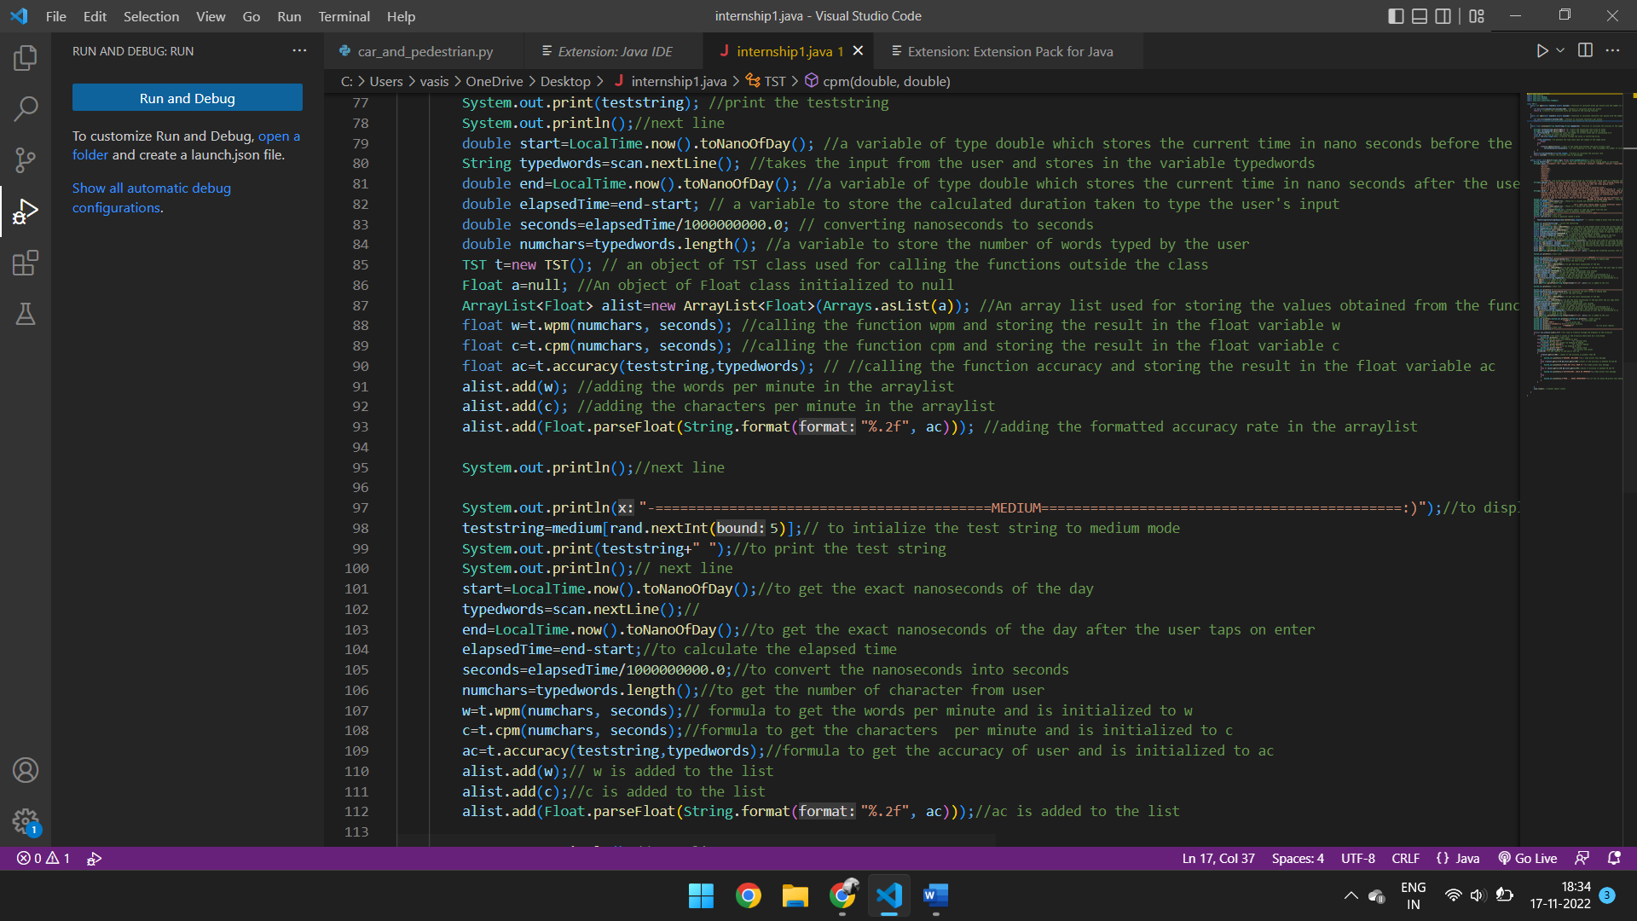

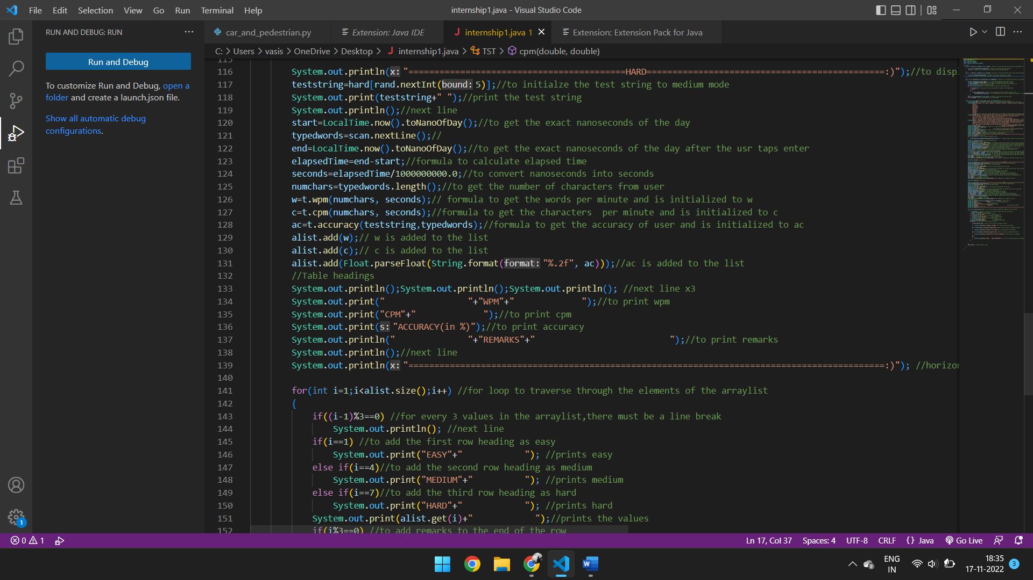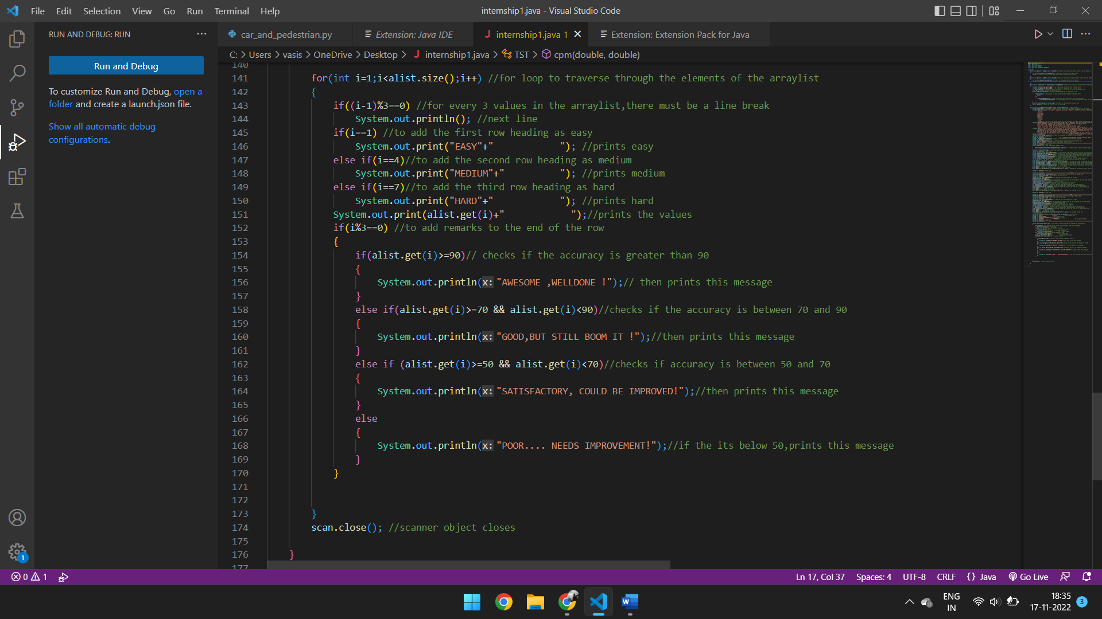

OUTPUT:

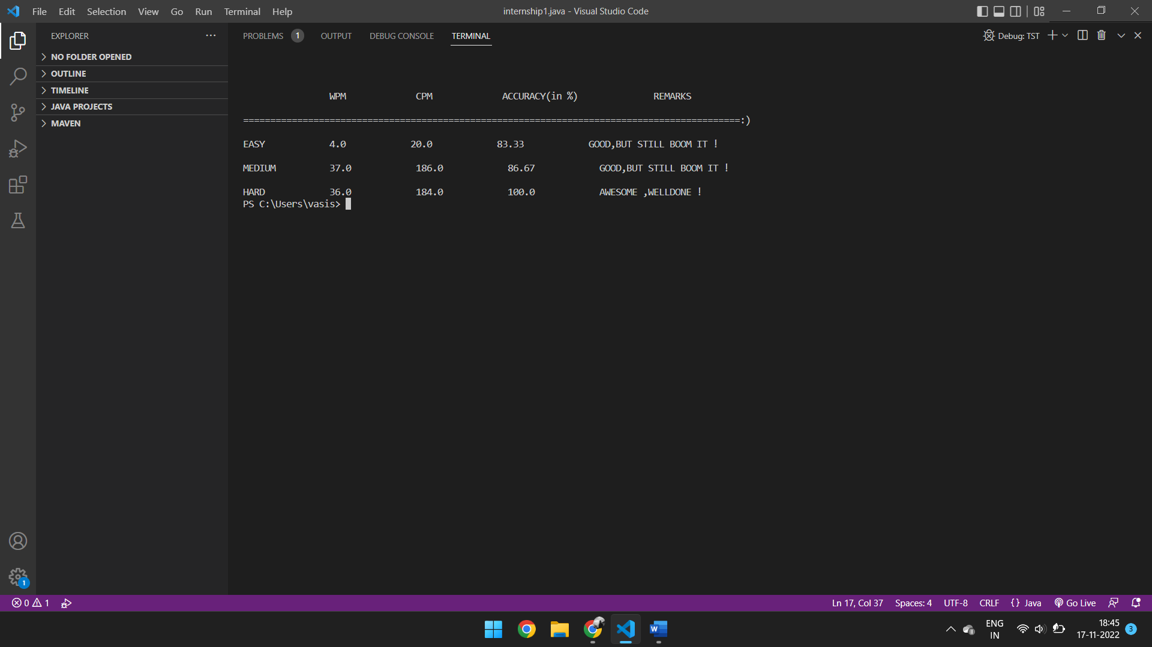

CONCLUSION:

The successful implementation of the TYPING SPEED CALCULATOR is done as per following the use of WPM(WORDS PER MINUTE) , CPM (CHARACTERS PER MINUTE ), ACCURACY of the typed words. The project uses the efficient use of java and advanced java concepts to develop this project into final successful result.

# BIBLIOGRAPHY:

* “Core Java™, Volume I--Fundamentals (8th Edition) “ , by Cay S. Horstmann, Prentice Hall; 8

edition (April 18, 2008).

* “Effective Java (2nd Edition)” , by Addison-Wesley; 2 edition (May 28, 2008) .
* “Java The Complete Reference, 8th Edition”, McGraw-Hill Osborne Media; 8 edition (June 22, 2011).
* A Programmer's Guide to Java SCJP Certification: A Comprehensive Primer (3rd Edition), Addison-Wesley Professional; 3 edition (December 29, 2008).
* “More Java Pitfalls: 50 New Time-Saving Solutions and Workarounds” , by Michael C. Daconta (Author), Kevin T. Smith (Author), Donald Avondolio (Author), W. Clay Richardson (Author), Wiley; 1 edition (February 3, 2003).
* “Head First Servlets and JSP: Passing the Sun Certified Web Component Developer Exam “, by Bryan Basham (Author), Kathy Sierra (Author), Bert Bates (Author), O'Reilly Media; Second Edition edition (April 1, 2008).
* “Head First Design Patterns”, Elisabeth Freeman (Author), Eric Freeman (Author), Bert Bates (Author), Kathy Sierra (Author), Elisabeth Robson (Author), O'Reilly Media; 1 edition (November 1, 2004)
* “EJB 3 in Action”, Debu Panda (Author), Reza Rahman (Author), Derek Lane (Author),

Manning Publications; 1 edition (April 16, 2007).

* “JBoss: A Developer's Notebook” , Norman Richards (Author), Sam Griffith (Author), O'Reilly
* Enterprise Java™ Security: Building Secure J2EE™ Applications, Marco Pistoia (Author), Nataraj Nagaratnam (Author), Larry Koved (Author), Anthony Nadalin (Author), Addison- Wesley Professional; 1 edition (February 27, 2004).

PAGE NO:07

* “Java EE 6 Development with NetBeans 7”, Author: David Heffelfinger, Published: June 2011, PACKT Publishing, UK. NetBeans IDE 7.0 Cookbook, Author: Rhawi Dantas, Published: May 2011, PACKT Publishing, UK
* “Art of Java Web Development: Struts, Tapestry, Commons, Velocity, JUnit, Axis, Cocoon,

InternetBeans, WebWork”, Neal Ford (Author), Manning Publications (November 1, 2003).

* “Struts 2 in Action”, Don Brown (Author), Chad Michael Davis (Author), Scott Stanlick

(Author), Manning Publications; 1 edition (May 1, 2008).

* “Hibernate in Action (In Action series)”, Christian Bauer (Author), Gavin King (Author), Manning Publications (August 1, 2004) “Web Services Essentials (O'Reilly XML)”, Ethan Cerami (Author), O'Reilly Media (February 2002) .
* “Object-Oriented Software Construction (Book/CD-ROM) (2nd Edition)” ,Bertrand Meyer

(Author), Prentice Hall; 2nd edition (March 21, 2000).

* Java Black Book, Steve Holzner (Author), Steven Holzner (Author), Paraglyph Press; Second Edition edition (July 1, 2002)